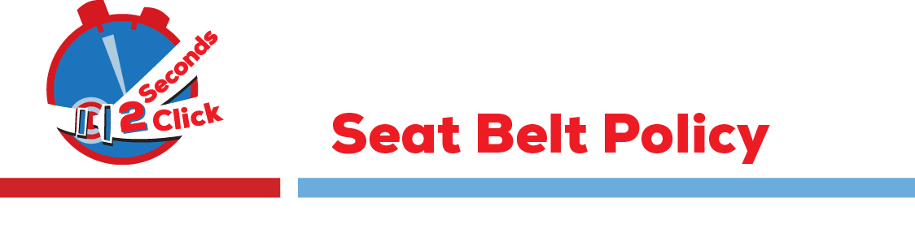

(Name of company/organization) recognizes that seat belts are extremely effective in preventing injuries and loss of life. We care about our employees, and want to make sure that no one is injured or killed in a tragedy that could have been prevented by the use of seat belts. Therefore, all employees of (Name of company/organization) must wear seat belts when operating a company-owned vehicle, or any vehicle on company premises or on company appropriate, child restraints when riding in a company-owned vehicle at any time, or in a personal vehicle being used for company business. All employees and their families are strongly encouraged to always use seat belts and the proper child restraints whenever they are driving or riding in any vehicle.

